ABG, VBG, CBG -> CHOICE ??
DR.P.C.VIJAYAKUMAR. D.A.,DNB.,MNAMS, Chief anaesthesiologist., Surya Hospitals., Chennai

Introduction :

Blood gas analysis is essential for management of patients in intensive care unit, it yields a valuable information about a variety of disease processes. It helps in the assessment and monitoring of patients with metabolic disturbances and to evaluate the acid base status, ventilation and oxygenation.

Blood gas analysis is an invasive method. There are non invasive methods of monitoring patient’s respiratory status, which include pulse oximetry, co- oximetry trans cutaneous monitoring of O₂ & CO₂, End-tidal carbon dioxide monitoring, near infra red spectroscopy (NIRS), but these non invasive does not measure PH, HCO₃, base excess, lactate.

Blood gas analysis is indicated in patients with severe respiratory (or) metabolic disorders, clinical features of hypoxia (or) hypercarbia, shock, sepsis, decreased cardiac output, renal failure and in patient’s who are on oxygen therapy. PH, PCO₂ can be directly measured from blood gas samples, HCO₃, BE, oxygen saturation can be calculated and reported from blood gas samples.

Blood gases can be obtained from the arteries, veins or capillaries.

ABG (Arterial blood gas analysis)

Arterial blood gases are most reliable, gold standard method, but require blood to be obtained from an artery.

Common sites for sampling:

- Radial artery
- Femoral artery
- Brachial artery
- Dorsalis pedis artery
- Axillary artery
- Umbilical artery( in neonates)

Radial artery is the most preferred site since it is accessible, easily positioned and is having collateral circulation. Allen’s test is used to assess the collateral circulation.
It may require an arterial line for frequent monitoring of blood gases. It can be safely done only by trained and medically qualified persons.

Potential complications of an ABG:

- Bruising (30%)
- Pain or tenderness (10%)
- Hematoma (5%)
- Arterial spasm (1.2 to 1.4%)
- Aneurysm
- Hemorrhage
- Ischemia
- Compression neuropathy
- Sepsis
- AV fistula

Precautions for collection of blood sample

(1) Heparin is acidic and lowers pH. Use heparin of lower strength (1000 units per ml instead of 5000 units per ml) or heplock solution.
(2) Use small volume of heparinised saline just for lubricating syringe and plunger. If volume is more, dissolved oxygen in heparinised saline may increase pO₂.
(3) Avoid air bubble and let syringe fill spontaneously.
(4) It is desirable to use a glass syringe as plastic syringes are permeable to air

(5) Sample may be collected in a heparinised capillary from hub of needle used to puncture artery.

The sample should be processed immediately, preferably within 30 minutes. blood sample should be stored at 4C, if it is not processed immediately. Blood is a living medium. The cells consume oxygen and produce CO₂. Drop in PO₂ depends on initial PO₂. If the latter is very high, significant drop may be noticed. Slush of ice (not cubes) should be used for storing samples till processing.

PARAMETER | HEPARIN* | AIR BUBBLE IN SAMPLE | DELAYED ANALYSIS
Po2 | No significant change | Elevated | Variable
Pco₂ | Lowered | No significant changes | Elevated
Ph | Unchanged | No significant changes | Lowered
An ABG gives the most accurate information regarding the arterial acid base status, adequacy of ventilation and oxygenation.

Why to use alternative?

- Avoid complications and pain
- Avoid invasive monitoring techniques such as indwelling catheter
- Reduce the number of ABG sampling
- Arterial access is not available

VBG (Venous blood gas analysis)

VBG may be required under certain circumstances when an ABG or CBG cannot be performed.
Peripheral venous sample obtained from a venipuncture, it should be done without tourniquet.
Central venous sample obtained from central line.
Mixed venous sample obtained from distal port of pulmonary artery catheter.
In cases like sepsis, shock, fever congestive heart failure where there is impaired circulation it is essential to assess mixed venous oxygen saturation (SVO₂).

CBG ( Capillary blood gas analysis)

Capillary blood gases are used for routine check of body’s respiratory status in case if it is difficult to obtain arterial blood. It is particularly more useful in small infants & children than adults.
It is least invasive and safest blood collecting technique and can be performed by all health care personal after minimal training. Capillary blood can be obtained by near painless skin puncture using a lancet or automated incision device that puncure the skin to the depth of just 1mm.
To obtain more accurate results capillary blood samples should be arterialized. Arterialization is increasing the local blood flow either by warming or application of vasodilating agent.

Sites for obtaining CBG:

It can be taken from heal of the infants after warming the heal (arterializing the capillary blood) or from the finger tips in neonates and children.

In case of adults it can be done with arterialized ear lobe sample

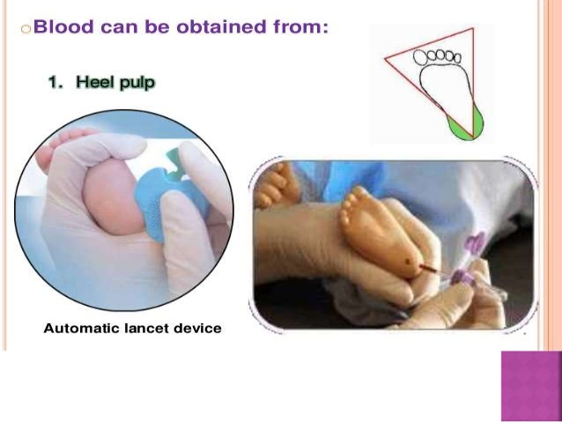

How arterialized capillary sample is taken

- Site – Finger, toe, heel or ear lobe
- Wrapping in warm pad (40-43 C) for 10 minutes
- Massage ear lobe for 2-3 minutes
- Heparinised capillary tube should be sealed after collecting sample with clay at one end
- Short steel wire is inserted then other end is sealed
- Steel wire is moved with magnet to mix the sample

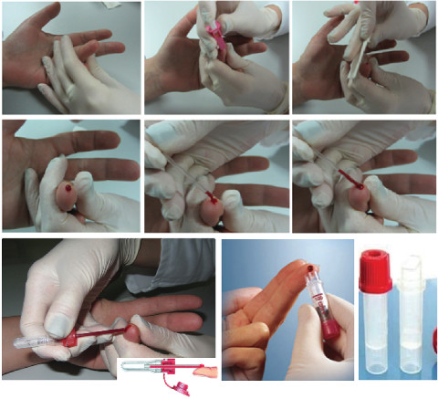

Correlation between the ABG, VBG & CBG

Normal Values

 | Arterial | Capillary | venous
PH | 7.35 - 7.45 | 7.35 - 7.45 | 7.32 - 7.42
PO2 | 90 – 100mmHg | 60 – 80mmHg | 24 – 48mmHg
PCO2 | 35 – 45mmHg | 35 – 45mmHg | 38 – 52mmHg
O2 saturation | 90 – 100% | 90 – 100% | 40 – 70%
HCO3 | 19 - 25 m Eq /L | 19 - 25 m Eq / L | 19 - 25 m Eq /L
Base excess | -3 to +3 | -3 to +3 | -3 to +3

Correlation between VBG & ABG

There is a good correlation in PH (pooled mean difference to 0.035 pH units), HCO3 (Mean difference – 1.41 mmol/L), Lactate (mean difference 0.08), Base excess (Mean difference 0.089 mmOL / L). venous PCO₂ correlates well with arterial PCO₂ in normocapneic individuals, correlation dissociates in case of hypercarbia (PCO₂ > 45mmHg) & in case of severe shock. Venous lactate correlation dissociates if lactate level is more than 2 mmol/ L. Arterial PO₂ is higher than the venous PO₂, there is a poor correlation between venous PO₂ & arterial PO₂.

Correlation between CBG & ABG

There is a good correlation in PH, PCO₂, HCO₃ & base excess, PO₂. The average correlation between capillary and arterial samples were 0.78 for PH, 0.73 for PCO2, 0.71 for base excess, 0.90 for HCO₃, 0.77 for PO₂ and 0.52 for SaO₂.

It has been proven that, there is a major correlation in PH, PCO₂ BE and HCO₃, and to a small extent PO₂, among ABG, VBG and CBG values even in the presence of hypothermia, hyperthermia and prolonged capillary refilling time. But in case of hypotension and poor systemic perfusion correlation in PO₂ between VBG & CBG was similar, but that correlation disappeared in ABG – VBG and ABG – CBG.

Limitations of VBG

VBG has limited value in determining the oxygenation status, continuous blood pressure monitoring where VBG clearly does not replace ABG. In cases, if it is unable to establish an IV access, difficult to obtain venous blood in pulseless patients, inability to obtain oxygen saturation by pulse oximetry like peripheral vasoconstriction, presence of abnormal haemoglobins, VBG has limited value.

Limitation of CBG

When there is a need for direct analysis of arterial blood, exact analysis of oxygenation CBG has limited values, hence CBG values are unreliable in the presence of hypotension. Capillaries continuously takes up oxygen to meet the metabolic needs of local tissue bed, this is also one of the reason why CBG does not exactly predict blood oxygenation status.

Inadequate warming of the site (Arterialization) prior to puncture may result in inaccurate prediction of PH, PCO₂, BE, HCO₃.

CBG is contraindicated in neonates of less than 24 hours of age.

Practical applications of VBG & CBG

VBG measures the acid base status and PO₂ of the venous blood after is has already passed completely through the capillary blood. The venous oxygen saturation and PO₂ may give some indication of how much oxygen remains after the tissue O₂ extraction. Hence VBG particularly central venous oxygen saturation is used to determine the adequacy of tissue perfusion and oxygen delivery .

VBG would be useful for decision making in the need for intubation, but not for monitoring ventilation and oxygenation particularly in emergency departments.

- ScvO₂(central venous oxygen saturation)is one of the clinical monitoring tools used to guide fluid resuscitation as part of the bundle in ‘early goal-directed therapy’ of septic shock^{1.2}
- A ScvO₂ < 70% was used as a trigger to increase DO₂ by increasing cardiac output or increasing haemoglobin once fluid resuscitation resulted in a target CVP of 8 – 12
- Using this bundle, Rivers demonstrated a decrease in mortality;
- Several studies have used SvO₂ (mixed venous oxygen saturation) monitoring in the peri operative setting.
- Goal directed transfusion triggers : SCVO₂< 70% is used as a transfusion trigger, for increasing Hct > 30% in critically ill patients.

CBG is indicated when ABG is indicated but arterial access is not available, assessment of initiation administration or change in therapeutic modalities (that is mechanical ventilation), monitoring the severity and progression of a documented disease process. Arterialized CBG can accurately predict the ABG values of PH, PCO2, BE and HCO3

Conclusion

To conclude ABG is the gold standard and most reliable method of assessing patient’s acid base status, adequacy of ventilation and oxygenation.
Given the well accepted accuracy of pulse oximetry, CBG & VBG analysis may be useful alternatives to arterial sample for assessing patient’s acid base status, in whom continuous BP recording & close monitoring of PaO₂ is not required .
CBG, VBG is more of pediatric and neonatal use than adults.

References :
- Yildizdas D, (correlation of simultaneously obtained capillary, venous and arterial blood gases of patient in peaediatric intensive care unit) Arch Dis child Feb; 89(2): 176-80.
- A zim Honarmond and Mohammadroza Safari (Prediction of arterial blood gas values from arterialized ear lobe blood gas values in patients treated with mechanical ventilation) Indian J critical care Med. 2008 Jul – Sep ; 12(3) : 96-101.
- Ratna N G B Tan, (Monitoring oxygenation and gas exchange in Neonatal intensive care units) 2015; 3 : 94 Nov 3. Doi : 10.3389/f ped. 2015. 00094.
- Kamran Heidari (correlation between capillary and arterial blood gas parameters in an ED) AMJ Emerg. Med. 2013 Feb 15; 13 (2) : 326 – 9 Epub 2012 Nov 15.
- Koch G, Wendal #. Comparison of pH, Carbon dioxide tension, standard bicarbonate and oxygentension in capillary blood and in arterial blood during the neonatal period. Acta paediata scand 1967; 56 : 10 – 16.
- Mclain B1, Evans J, Dear PFR. Comparison of capillary and arterial blood gas measurements in neonates. Arch Dis child 1988; 63: 743 – 747.
- Meites S. Skin puncture and blood collecting techniques for infants : Update and problems. In : Meites S, ed. Pediatric clinical chemistry, 1989 : 5 – 15.
- Holley A. Lukin W. Paratz J. Hawkins T. Boots R, LKipman J, Review article: Part one : Goal-directed resuscitation – which goals? Haemodynamic targets. Emergency Medicine Australasia (2012) 24. 14-22
- Rhodes A, Bennett DE. Early goal-directed therapy: An evidence- based review. Crit care Med 2004; 32: S448-450
- Shaperd SJ. Pearse R. Role of Central and Mixed Venous Oxygen Saturation Measurement in Perioperative Care. Anesthesiology 2009; 111 : 649 – 656.
- Venous pH can safely replace arterial p H in the initial evaluation of patients in the emergency department A-M Kelly, R McAlpine, E Kyle
- G Malaresha, Nishith K Singh, Ankur Bharija, Bhavya Rehani and Ashish Goel
Comparison of arterial and venous pH, Bicarbonate, PCO 2 and in initial emergency department assessment Emerg. Med. J. 2007;24: 569-571

